Smart Street Light

# Idea:

As we know that a lot of electricity is wasted in street light where it is not required. This model is based on Arduino Uno to save the wasted electricity by lighting only those street lights under which something is passing by. By this we save a lot of electricity and also make the street light system cost efficient.

# Components Used:

* Arduino UNO R3
* Infrared Sensor : 4 Ps
* LED (10mm)
* Breadboard (Mini)
* Jumper Wires (Male-Female and Male-Male)
* Computer Wire(To give power to arduino)

# Code Description:

**In void setup() block** all the pinModes for LEDs and IR sensors are assigned.

**In void loop() block**  for each IR sensor I have checked whether it has detected something in front of it, and if it detects an object three streetlights in its vicinity is turned ON, also to keep the lights in ON state for few milliseconds after the objects passes by ,I have used a variable d1 (for IR sensor 1) to add some delay time and then turn it OFF.

# Illustrations:

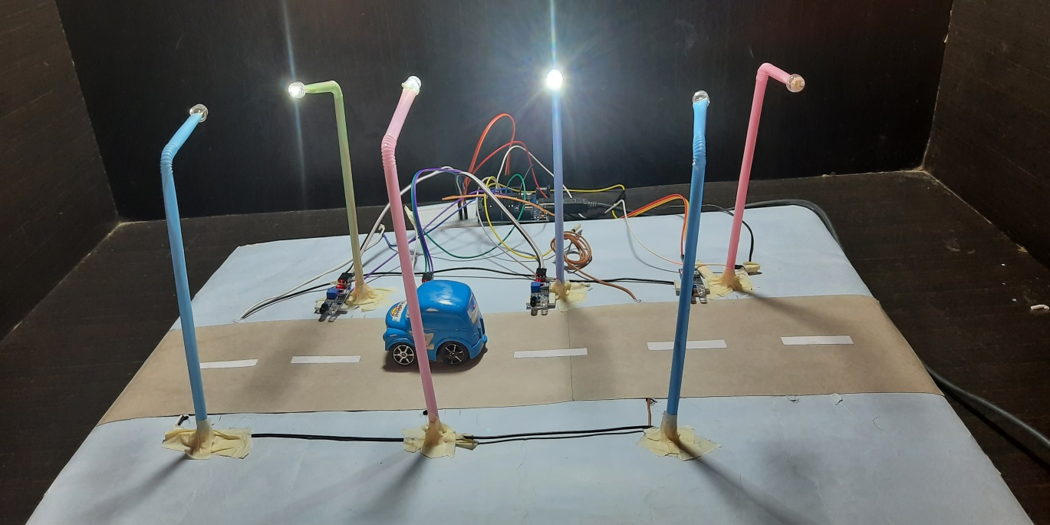

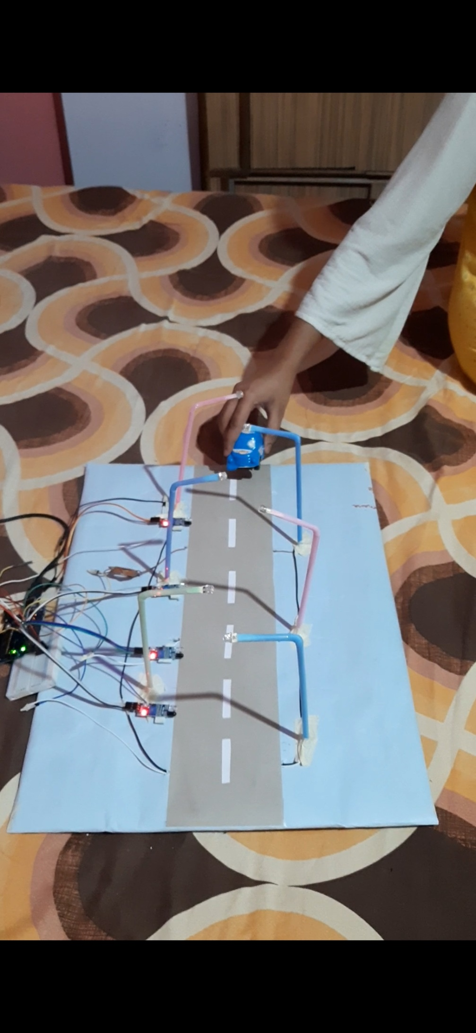

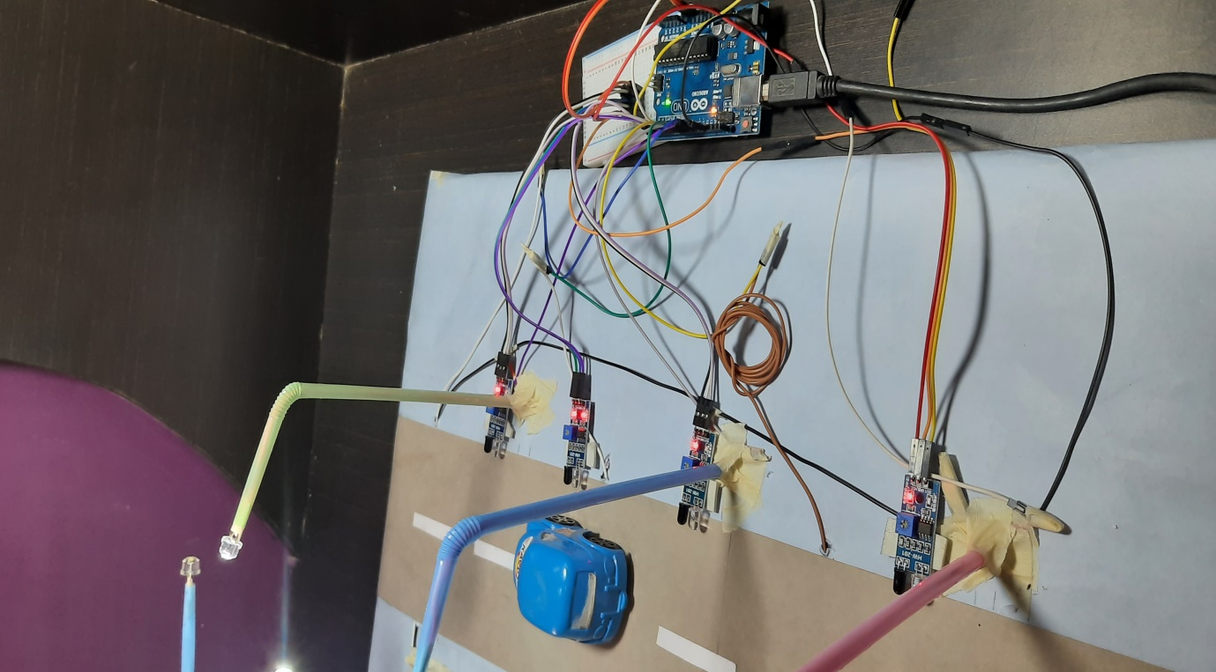

## Circuit Diagram:

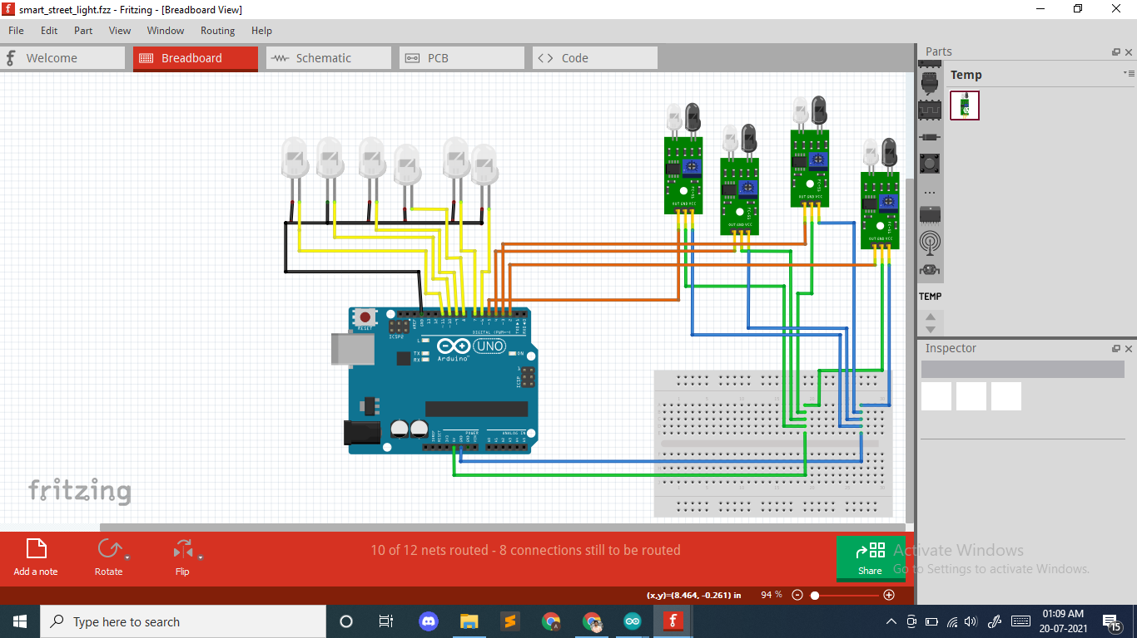

# Takeaway:

This is my first practical project so I have learned a lot about arduino (how to code it and make connections) . In this I had to work a little for making connections as the wires are very thin, and adding some delay time to LEDs , as by simply using delay() function whole process gets delayed and model don’t work as desired , Rest coding and other works was pretty easy.

There is one bug that when a sensor senses an object it lights three LEDs but one of them glows more bright than the other two. Hope so I will able to fix it soon.

Thank You!!